**PROJECT REPORT**

ON

**BOUNCING BALL GAME**

Submitted in partial fulfillment of the

Requirements for the award of

**Degree of Bachelor of Technology in Computer Science & Engineering**



SUBMITTED BY:

**Prajjawal Kumar (2200900100100)**

SUBMITTED TO:

**Ms. Shahina Anjum**

&

**Ms. Arushi Gupta**

**Department of Computer Science & Engineering**

IEC college OF ENGINEERING AND TECHNOLOGY

Greater Noida, U.P.

**TABLE OF CONTENTS** Page

DECLARATION ................................................................................................... ii

CERTIFICATE ..................................................................................................... iii

ACKNOWLEDGEMENTS .................................................................................. iv

ABSTRACT ........................................................................................................... v

LIST OF FIGURES................................................................................................ vi

CHAPTER 1 (INTRODUCTION)...................................................................... 1

1.1. ................................................................................................................. 5

CHAPTER 2 (DESCRIPTION) .......................................................................... 13

2.1. .................................................................................................................. 15

2.2. .................................................................................................................. 17

2.3. .................................................................................................................. 19

2.4. .................................................................................................................. 20

2.5. .................................................................................................................. 21

CHAPTER 3 (SKILLS ACQUIRED) .................................................................. 30

3.1. ................................................................................................................ 36

3.2. ................................................................................................................ 39

CHAPTER 4 (CHALLENGES FACED) ............................................................ 30

CHAPTER 5 (FUTURE SCOPE) ......................................................................... 40

CHAPTER 5 (CONCLUSION) .......................................................................... 40

REFERENCES... .................................................................................................... 49

***DECLARATION***

*I hereby declare that this submission is my own work and that, to the best of my knowledge and belief, it contains no material previously published or written by another person nor material which to a substantial extent has been accepted for the award of any other degree or diploma of the university or other institute of higher learning, except where due acknowledgment has been made in the text.*

*Signature*

*Name*

*Roll No.*

*Date*

***CERTIFICATE***

*This is to certify that Mr. / Ms.___________________________ has partially completed / completed / not completed the 6-Month Industrial Training during the period from _______ to_______ in our Organization / Industry as a Partial Fulfillment of Degree of Bachelor of Technology in Computer Science Engineering. He / She was trained in the field of ______________________________ .*

**Signature & Seal of Training Manager**

#### Note: This certificate must be typed on the company letter head.

ACKNOWLEDGEMENT

*It gives us a great sense of pleasure to present the report of the B. Tech Project undertaken during B. Tech. Final Year. We owe special debt of gratitude to Professor Shahina Anjum, Department of Computer Science & Engineering, IEC College of Engineering & Technology, Greater Noida for his constant support and guidance throughout the course of our work. His sincerity, thoroughness and perseverance have been a constant source of inspiration for us. It is only his cognizant efforts that our endeavors have seen light of the day.*

*We also take the opportunity to acknowledge the contribution of Professor Dr. B. Sharan, Head, Department of Computer Science & Engineering, IEC College of Engineering & Technology, Greater Noida for his full support and assistance during the development of the project.*

*We also do not like to miss the opportunity to acknowledge the contribution of all faculty members of the department for their kind assistance and cooperation during the development of our project. Last but not the least, we acknowledge our friends for their contribution in the completion of the project.*

*Signature:*

*Name :*

*Roll No.:*

*Date :*

***ABSTRACT***

This project presents the development of a Bouncing Ball Game using Python and the PyGame library. The game involves a ball that bounces off a paddle controlled by the player, with the objective of preventing the ball from falling. It integrates key features such as a lives system, high score tracking, restart and quit options, background image, and sound effects to enhance the gaming experience. The use of the PyGame library enabled efficient handling of game loops, collision detection, event management, graphics, and audio integration. This project not only provides an engaging and interactive game but also serves as a foundation for future enhancements such as difficulty levels, power-ups, and brick-breaking mechanics.

**List of Figures**

Figure No. Title Page No.

Figure 2.5.2 Gameplay………... ……………………..……………………….5

Figure 2.5.2 Gameover Interface...…………………………………………….5

Figure 2.5.3 Record.…………………………………………………………...6

Figure 2.5.4 Flowchart…………………………………………………………6

**CHAPTER 1: INTRODUCTION**

1.1 Introduction

Game development has become one of the most effective ways to learn programming concepts, problem-solving, and logical thinking. This project focuses on creating a Bouncing Ball Game using Python and the PyGame library, a popular framework for building 2D games. The project aims to design an interactive and engaging game that demonstrates the use of fundamental game development techniques such as event handling, collision detection, animations, and sound integration.

In the game, the player controls a paddle to prevent the ball from falling off the screen, while features like a lives system, high score tracking, restart and quit options, background graphics, and sound effects add depth and replay value. The PyGame library provides built-in support for managing graphics, user input, and audio, which makes it an ideal choice for this project.

This project not only showcases the application of programming in entertainment and multimedia but also strengthens understanding of core computer science concepts like loops, conditions, object-oriented programming, and real-time event-driven execution. It serves as a strong foundation for building more advanced games with additional features such as multiple levels, power-ups, and brick-breaking mechanics.

**CHAPTER 2: DESCRIPTION**

The Bouncing Ball Game is an interactive 2D arcade-style game developed using Python and the Pygame library. The game is designed to provide both entertainment and learning value by demonstrating the integration of programming concepts with multimedia elements such as graphics and sound. It showcases how Python can be used not only for data processing and software development but also for game design and interactive applications.

**2.1 Gameplay Overview**

The game revolves around a ball that continuously bounces across the screen. The player controls a paddle positioned at the bottom, and the primary objective is to prevent the ball from falling past the paddle. If the player successfully hits the ball with the paddle, the ball bounces back, and the game continues. Missing the ball results in the loss of a life. The game ends when the player loses all available lives, after which a Game Over screen is displayed.

**2.2 Key Features**

1. Ball and Paddle Mechanics – Real-time ball movement with collision detection against walls and the paddle.
2. Lives System – Players are given multiple chances, adding a challenge factor.
3. Score and High Score Tracking – The score increases as the ball is kept in play, while the highest score is recorded for competitive replay.
4. Game Over Interface – Displays the final score, high score, and options to restart or quit the game.
5. Restart and Quit Buttons – Allow players to conveniently replay or exit the game.
6. Background Image and Sound Effects – Enhance the visual and audio appeal, creating an engaging user experience.

**2.3 Technical Implementation**

The project is implemented using the Pygame library, which provides essential tools for 2D game development such as:

* Event Handling – Capturing keyboard inputs to move the paddle.
* Collision Detection – Checking interactions between the ball, paddle, and screen boundaries.
* Game Loop Management – Running continuous updates for motion, logic, and rendering.
* Graphics Rendering – Displaying the paddle, ball, background image, and interface elements.
* Audio Integration – Playing sound effects for collisions and game events.

The entire game is controlled through a main game loop that updates positions, checks conditions, and refreshes the display in real-time. The modular structure allows easy extension and customization of features.

**2.4 Significance**

This project serves as a practical implementation of programming concepts such as loops, conditions, real-time updates, object-oriented design, and state management. It demonstrates how a simple idea can be expanded into a polished application by combining logic with creativity. Moreover, the project builds a strong foundation for developing advanced games by adding features like power-ups, multiple levels, target-breaking (Arkanoid style), and difficulty scaling.

**2.5 Screenshort**

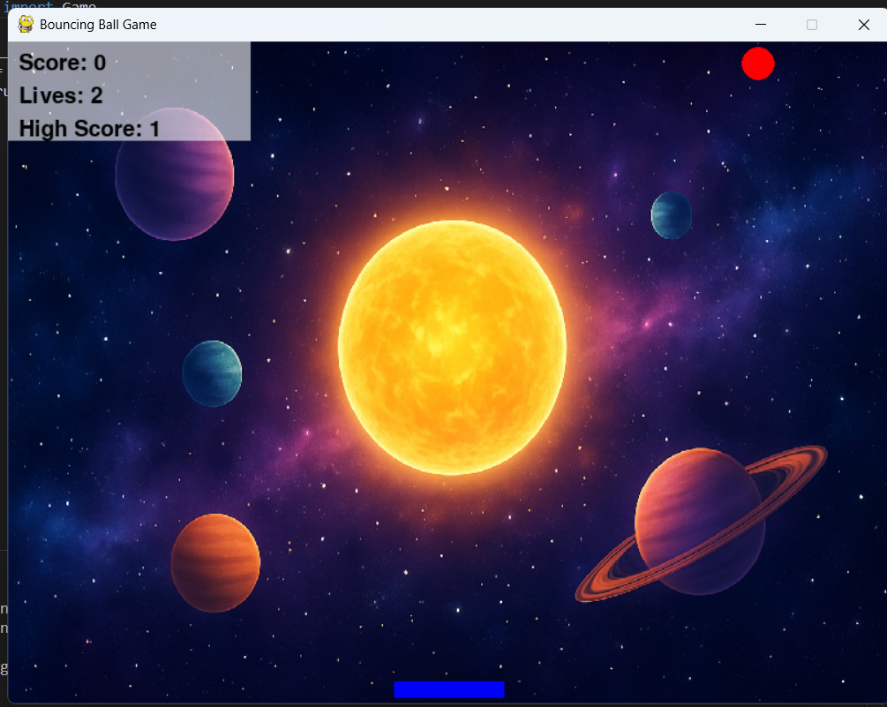

Fig 2.5.1: Gameplay

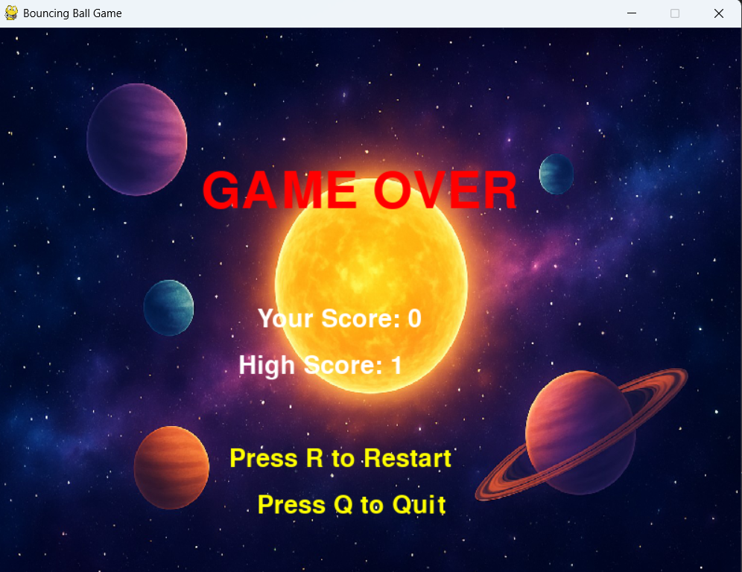

Fig 2.5.2: Game Over Interface

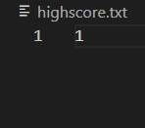

Fig 2.5.3: Record

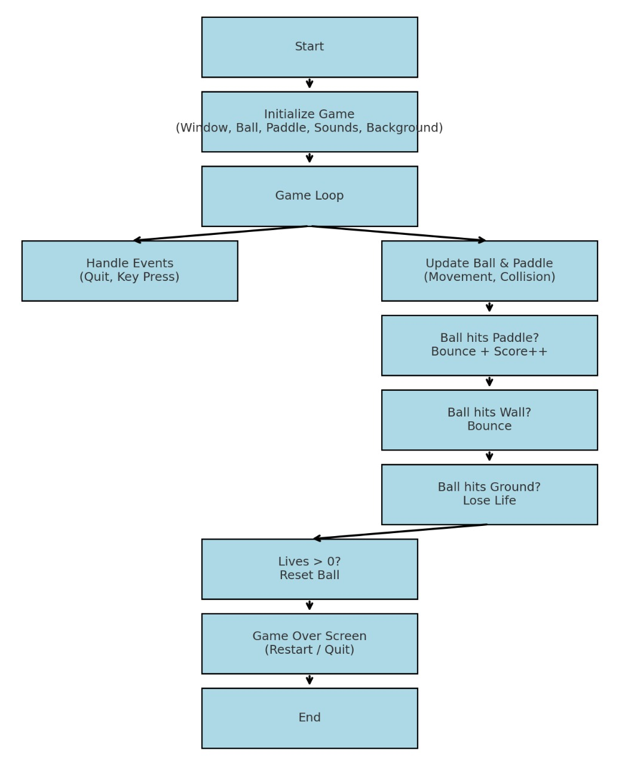

Fig 2.5.4: Flowchart

**CHAPTER 3: SKILLS AQUIRED**

The development of the Bouncing Ball Game using Python and the Pygame library provided an opportunity to learn and strengthen a wide range of technical as well as soft skills. These skills not only improved programming knowledge but also enhanced problem-solving, creativity, and project management abilities.

* 1. Technical Skills

3.1.1 Python Programming Fundamentals

* + Reinforced understanding of core programming concepts such as variables, loops, conditionals, and functions.
  + Applied modular programming principles to keep the code organized and easy to maintain.

3.1.2 Pygame Library Proficiency

* + Gained hands-on experience with one of the most widely used Python libraries for game development.
  + Learned to implement event handling, real-time graphics rendering, collision detection, and sound integration.

3.1.3 Game Loop and Real-time Processing

* + Understood the structure and importance of a game loop in controlling the flow of the game.
  + Implemented continuous updates for ball movement, paddle control, collision checking, and screen refresh.

3.1.4 Collision Detection and Physics

* + Designed logic to detect ball collisions with the paddle, walls, and game boundaries.
  + Applied basic physics concepts like reflection angles to make ball movement more realistic.

3.1.5 Graphics and User Interface Design

* + Integrated background images and paddle/ball graphics for better visual appeal.
  + Designed Game Over screens, restart/quit buttons, and score displays to improve user interaction.

3.1.6 Audio Integration

* + Added sound effects for paddle hits, wall collisions, and game over events.
  + Learned how to manage background music and sound playback using Pygame’s mixer module.

3.1.7 State and Data Management

* + Implemented multiple game states: running, game over, restart, and quit.
  + Applied file handling to save and retrieve the high score across sessions.

3.1.8 Debugging and Optimization

* + Improved debugging techniques by testing different scenarios (e.g., ball speed, paddle collisions).
  + Enhanced performance by structuring efficient update loops and avoiding redundant computations.
  1. Soft Skills

3.2.1 Problem-Solving

* + Tackled challenges such as handling unpredictable ball trajectories, ensuring smooth collision detection, and managing game speed.
  + Broke down complex problems into smaller, manageable tasks for implementation.

3.2.2 Creativity and Innovation

* + Designed engaging features like the high score system, lives counter, restart/quit options, and multimedia integration.
  + Explored ideas for making the game more interactive and enjoyable for players.

3.2.3 Time Management and Planning

* + Divided the project into stages: planning, coding, testing, and enhancement.
  + Completed the project within deadlines while ensuring quality and completeness.

3.2.4 Analytical Thinking

* + Analyzed how different code segments interact within the game loop.
  + Understood the importance of balancing functionality, performance, and user experience.

3.2.5 User-Centered Design Approach

* + Focused on making the game simple to understand, easy to play, and fun to engage with.
  + Considered player experience while designing controls, scoring, and interface layout.

**CHAPTER 4: CHALLENGES FACED**

The development of the Bouncing Ball Game using Python and the PyGame library was a highly enriching experience, but it also came with several challenges. These challenges occurred at different stages of the project—from the initial setup to the final polishing—and overcoming them contributed significantly to learning and skill development.

1. Collision Detection Issues

One of the most difficult aspects was designing accurate collision detection between the ball, paddle, and screen boundaries.

* Initially, the ball sometimes passed through the paddle without bouncing back due to timing mismatches between the ball’s speed and the frame update rate.
* Calculating the correct reflection angles for the ball was also challenging, especially when it hit the paddle at the edges.
* After multiple trials and debugging, adjustments were made in the collision logic to ensure the ball bounced naturally, making gameplay smoother and more realistic.

2. Game Loop and Real-time Updates

Managing the game loop effectively was another major challenge.

* The loop needed to continuously update ball motion, detect collisions, process user input, update scores, and refresh the screen simultaneously.
* At first, issues like lagging frames and uneven ball speed appeared.
* Through optimization (such as controlling frame rates with pygame.time.Clock()), these problems were resolved, resulting in a consistent and fluid gameplay experience.

3. Speed and Difficulty Balancing

Balancing the ball’s speed and overall game difficulty was tricky.

* If the ball was too slow, the game felt uninteresting; if it was too fast, it became frustrating and nearly impossible to play.
* After experimenting with different values, a progressive difficulty mechanism was introduced where the ball’s speed increased slightly as the score went up, making the game both challenging and engaging.

4. High Score Storage and File Handling

Implementing a high score system with permanent storage was another challenge.

* Initially, the high score reset every time the game restarted, which reduced replay value.
* The solution was to use file handling to save the high score in a text file and load it whenever the game started.
* Debugging file read/write errors was time-consuming, but it provided valuable learning in handling external files with Python.

5. Graphics and User Interface Design

Making the game visually appealing was not as straightforward as expected.

* Scaling and positioning the background image to fit perfectly within the game window required careful adjustments.
* Designing the Game Over screen with options to restart and quit was initially confusing, especially handling user clicks and button states.
* These challenges were resolved by experimenting with Pygame’s drawing and event-handling functions, resulting in a polished and interactive interface.

6. Sound Integration

Adding sound effects and background music caused some technical difficulties.

* At first, the sounds did not synchronize properly with events (for example, the paddle hit sound played with a delay).
* There were also issues with looping background music and controlling volume.
* By learning Pygame’s mixer module thoroughly, these problems were solved, giving the game a more immersive feel.

7. Debugging Complex Interactions

Debugging was one of the most time-consuming challenges.

* When multiple actions occurred simultaneously (like the ball hitting the paddle, a life being lost, and the score updating), unexpected bugs appeared.
* Step-by-step testing, printing debug values, and isolating functions helped track down and resolve these issues.

8. Time Management and Project Planning

Balancing coding, debugging, feature enhancements, and report writing within limited time was also challenging.

* At first, too much time was spent on minor improvements, which delayed major functionality.
* Later, tasks were prioritized into “must-have” (gameplay, scoring, lives) and “good-to-have” (sound, background, restart menu), which helped in completing the project on time.

9. Learning Curve of Pygame

Since this was one of the first projects using the Pygame library, there was a steep learning curve.

* Functions for event handling, screen updates, drawing shapes, and sound playback were initially unfamiliar.
* By going through documentation, examples, and trial-and-error, Pygame was gradually mastered, and the library’s potential became clearer.

**CHAPTER 5: FUTURE SCOPE**

Although the Bouncing Ball Game is fully functional with essential features such as scoring, lives, high score tracking, restart/quit options, and multimedia integration, there is significant potential to enhance and expand the game. The following future improvements can make the project more engaging, challenging, and professional:

1. Difficulty Progression

* Introduce multiple difficulty levels (Easy, Medium, Hard).
* Increase ball speed or reduce paddle size as the player’s score increases, making the game progressively harder.

2. Power-ups and Power-downs

* Add collectible items that fall from the top when the ball hits certain areas.
* Examples:
  + Power-ups → Larger paddle, slower ball, extra life, multiple balls.
  + Power-downs → Smaller paddle, faster ball, reversed controls.

3. Multiple Balls Gameplay

* Introduce multiple balls after reaching certain score milestones.
* Increases complexity and improves the challenge factor.

4. Brick/Target System (Arkanoid Style)

* Add breakable bricks at the top of the screen.
* Player must destroy all bricks using the ball to complete a level.
* Different bricks could have varying durability (1-hit, 2-hit, unbreakable).

5. Advanced Graphics & Animations

* Introduce animated backgrounds and particle effects when the ball hits surfaces.
* Add character themes or level-based designs to make visuals more attractive.

6. Improved Sound & Music System

* Allow background music selection.
* Add different sound effects for paddle hit, wall hit, and game over.
* Introduce a volume control or mute option in the settings.

7. Pause Menu and Settings

* Implement a Pause/Resume feature during gameplay.
* Create a settings menu with options for sound on/off, difficulty, and controls.

8. Multiplayer Mode

* Add a two-player mode where players control separate paddles (one at the bottom, one at the top) competing or cooperating.

9. Saving Player Profiles

* Allow players to create profiles and save progress.
* Store individual high scores, achievements, and difficulty preferences.

10. Packaging and Deployment

* Convert the Python project into a standalone executable (.exe) file using tools like PyInstaller, making it easier to distribute and play without Python installation.
* Eventually, the game could be ported to Android or Web platforms.

**CHAPTER 6: CONCLUSIONS**

The development of the Bouncing Ball Game using Python and the PyGame library successfully demonstrated how fundamental programming concepts can be applied to create an interactive and engaging application. The project incorporated essential features such as ball–paddle mechanics, lives system, high score tracking, background image, sound effects, and restart/quit options, resulting in a complete and polished game.

Through this project, significant learning outcomes were achieved in the areas of Python programming, event handling, collision detection, game loop management, graphics integration, audio handling, and file management. In addition, the process enhanced important soft skills such as problem-solving, creativity, debugging, and time management.

Overall, the project not only met its objectives but also laid the foundation for more advanced game development projects. With future enhancements like difficulty progression, power-ups, multiple levels, and multiplayer features, the game has strong potential to evolve into a more complex and professional-quality product.

**REFERENCES**

7.1 Python Software Foundation. *Python Documentation.* Available at: [https://www.python.org/doc/](https://www.python.org/doc/?utm_source=chatgpt.com)

7.2 Pygame Community. *Pygame Documentation.* Available at: https://www.pygame.org/docs/

7.3 Sweigart, A. (2015). *Invent Your Own Computer Games with Python.* No Starch Press.

7.4 TutorialsPoint. *Python Game Development with Pygame.* Available at: https://www.tutorialspoint.com/pygame/index.htm

7.5 GeeksforGeeks *Introduction to Pygame.* Available at: https://www.geeksforgeeks.org/introduction-to-pygame/

7.6 Online forums and developer communities such as **Stack Overflow** for debugging and problem-solving assistance.